 | CASE STUDY 16:  An organization registers a contact person.

Objective:
- To register a reference record containing contact information using the BCH Management Centre.

References:
- Training Site for the BCH Management Centre (Go to http://bch.cbd.int > Resources > Training Site of the BCH)
- Training Manual 6: Registering Information in the BCH Central Portal
- Training Manual 8: Registering Reference Information in the BCH Central Portal

Scenario:

As the information officer for a biosafety organization, you are likely to be using the BCH to register several records where you will be the contact person for further information. In order to avoid having to type in this information several times, you want to create a record containing your contact details for later reference. Your business card is attached below.
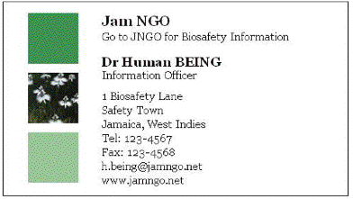

 | CASE STUDY 16:  An organization registers a contact person.

TRAINER NOTES

Training Objective:
Experience the process of using the BCH Management Centre to create a new core reference record.

Requirements:
A BCH account (registered as a general user), capacity-building organization or government, and access to the BCH.

Notes:
- Users can work singly or in small groups for this exercise.
- Participants need to have their own BCH account ready. They will login the BCH Training Site using their own BCH account. Refer to MO06 Training Manual for details on how to create a BCH account.
- It is recommended for you to setup your own Training Space for your workshop before you start this exercise. Otherwise, the participants can select the “Public BCH Training” training space.

- Records should be kept in the Management Centre for use in later exercises.
- If you are unable to access the BCH, users could fill out the details on a hard copy of the common format.
- At the end of the exercise, the instructor (logged in with the role “Administrator: BCH Training Site”) will need to validate completed records so that participants can access them through the Biosafety Information Resource.
- Users can then observe the “record status” – link on the left bar

The international dialing code for Jamaica is +1-876.

